The children at Whangarei's St Francs Xavier School have been going on a time travel this week, exploring everything from Ancient Egypt, through Ancient Rome, the Mayan age, the 1960s and into the future, before returning home again.
The youngsters have been on an exciting journey - and taking packed audiences with them - as they perform the play Uncle Crumble's Mad Machine over two nights and an afternoon.
The play looks at what happens when four children are told "don't touch that big red button" on the time machine, but do so anyway.
What follows is a fun adventure through time, meeting some very famous, and some not-so-famous characters along the way.Uncle Crumble's Mad Machine was performed at the school on Tuesday and Thursday nights and yesterday afternoon.
Northern Advocate photographer Michael Cunningham went along for the ride.
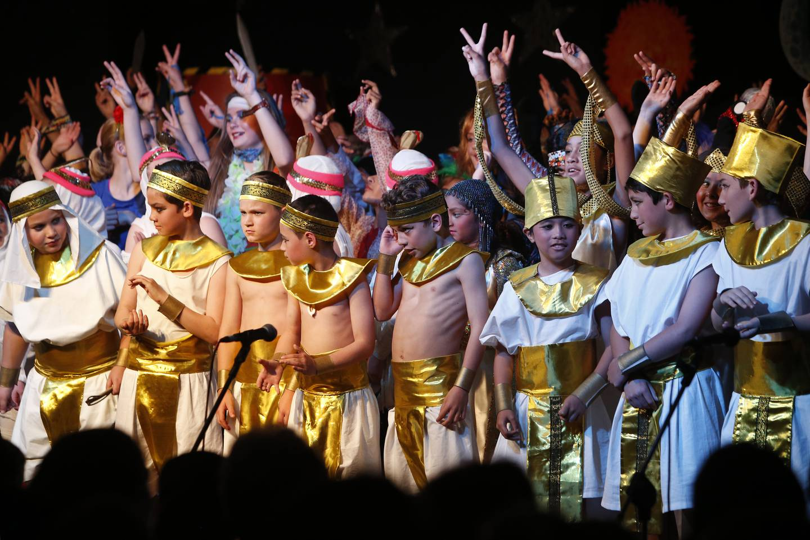Performers gather at the end of St Francis Xavier Catholic School's production of Uncle Crumble's Mad Machine.

